JAVA PRACTICE SHEET (02/02/2026 – 07/02/2026)
1.
Given an array and a range a, b. The task is to partition the array around the range
such that the array is divided into three parts.
1) All elements smaller than a come first.
2) All elements in range a to b come next.
3) All elements greater than b appear in the end.
The individual elements of three sets can appear in any order. You are required to
return the modified array.
Note: The generated output is true if you modify the given array successfully.
Otherwise false.
Geeky Challenge: Solve this problem in O(n) time complexity.
Examples:
Input: arr[] = [1, 2, 3, 3, 4], a = 1, b = 2
Output: true
Explanation: One possible arrangement is: {1, 2, 3, 3, 4}. If you return a valid
arrangement, output will be true.
Input: arr[] = [1, 4, 3, 6, 2, 1], a = 1, b = 3
Output: true
Explanation: One possible arrangement is: {1, 3, 2, 1, 4, 6}. If you return a valid
arrangement, output will be true.
Sol
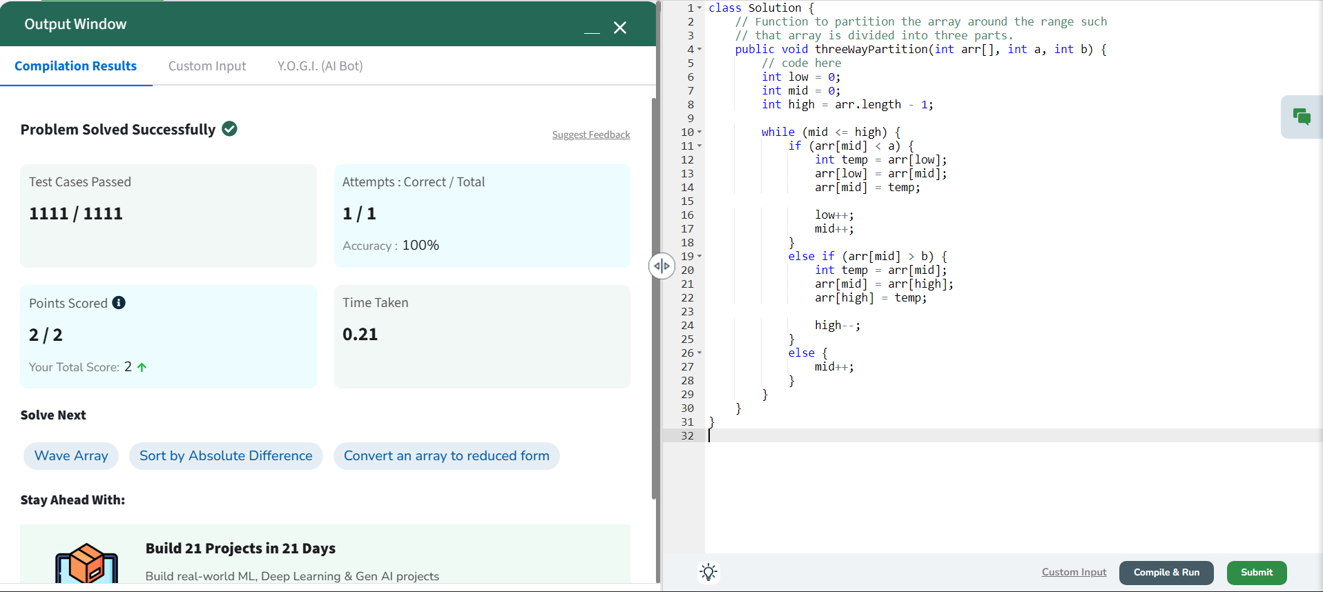
2.
Given an array arr and a number k. One can apply a swap operation on the array any
number of times, i.e choose any two index i and j (i < j) and swap arr[i] , arr[j] . Find
the minimum number of swaps required to bring all the numbers less than or equal
to k together, i.e. make them a contiguous subarray.
Examples :
Input: arr[] = [2, 1, 5, 6, 3], k = 3
Output: 1
Explanation: To bring elements 2, 1, 3 together, swap index 2 with 4 (0-based
indexing), i.e. element arr[2] = 5 with arr[4] = 3 such that final array will be- arr[] = [2,
1, 3, 6, 5]
Input: arr[] = [2, 7, 9, 5, 8, 7, 4], k = 6
Output: 2
Explanation: To bring elements 2, 5, 4 together, swap index 0 with 2 (0-based
indexing) and index 4 with 6 (0-based indexing) such that final array will be- arr[] =
[9, 7, 2, 5, 4, 7, 8]
Input: arr[] = [2, 4, 5, 3, 6, 1, 8], k = 6
Output: 0
Sol
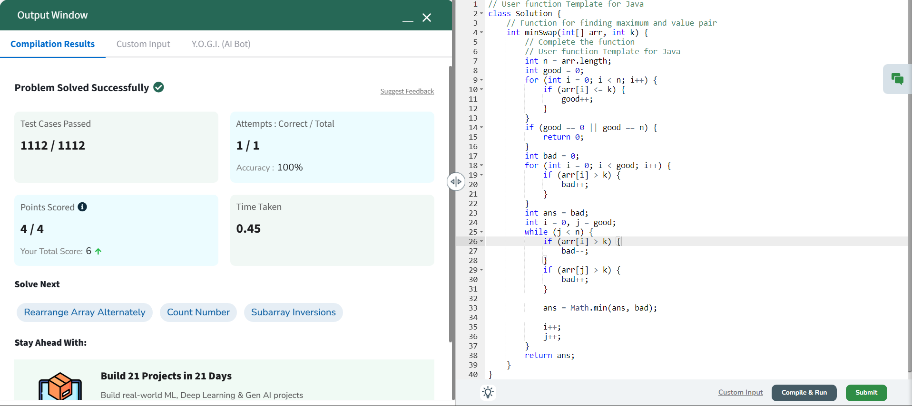
3.
You are given an m x n integer matrix matrix with the following two properties:
• Each row is sorted in non-decreasing order.
• The first integer of each row is greater than the last integer of the previous row.
Given an integer target, return true if target is in matrix or false otherwise.
You must write a solution in O(log(m * n)) time complexity.
Example 1:
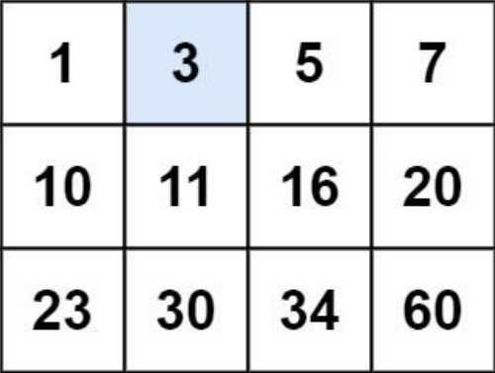
Input: matrix = [[1,3,5,7],[10,11,16,20],[23,30,34,60]], target = 3
Output: true
Example 2:
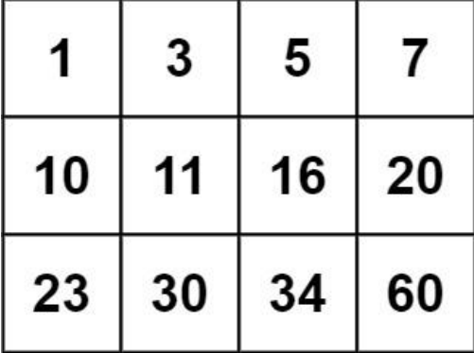
Input: matrix = [[1,3,5,7],[10,11,16,20],[23,30,34,60]], target = 13
Output: false
Sol
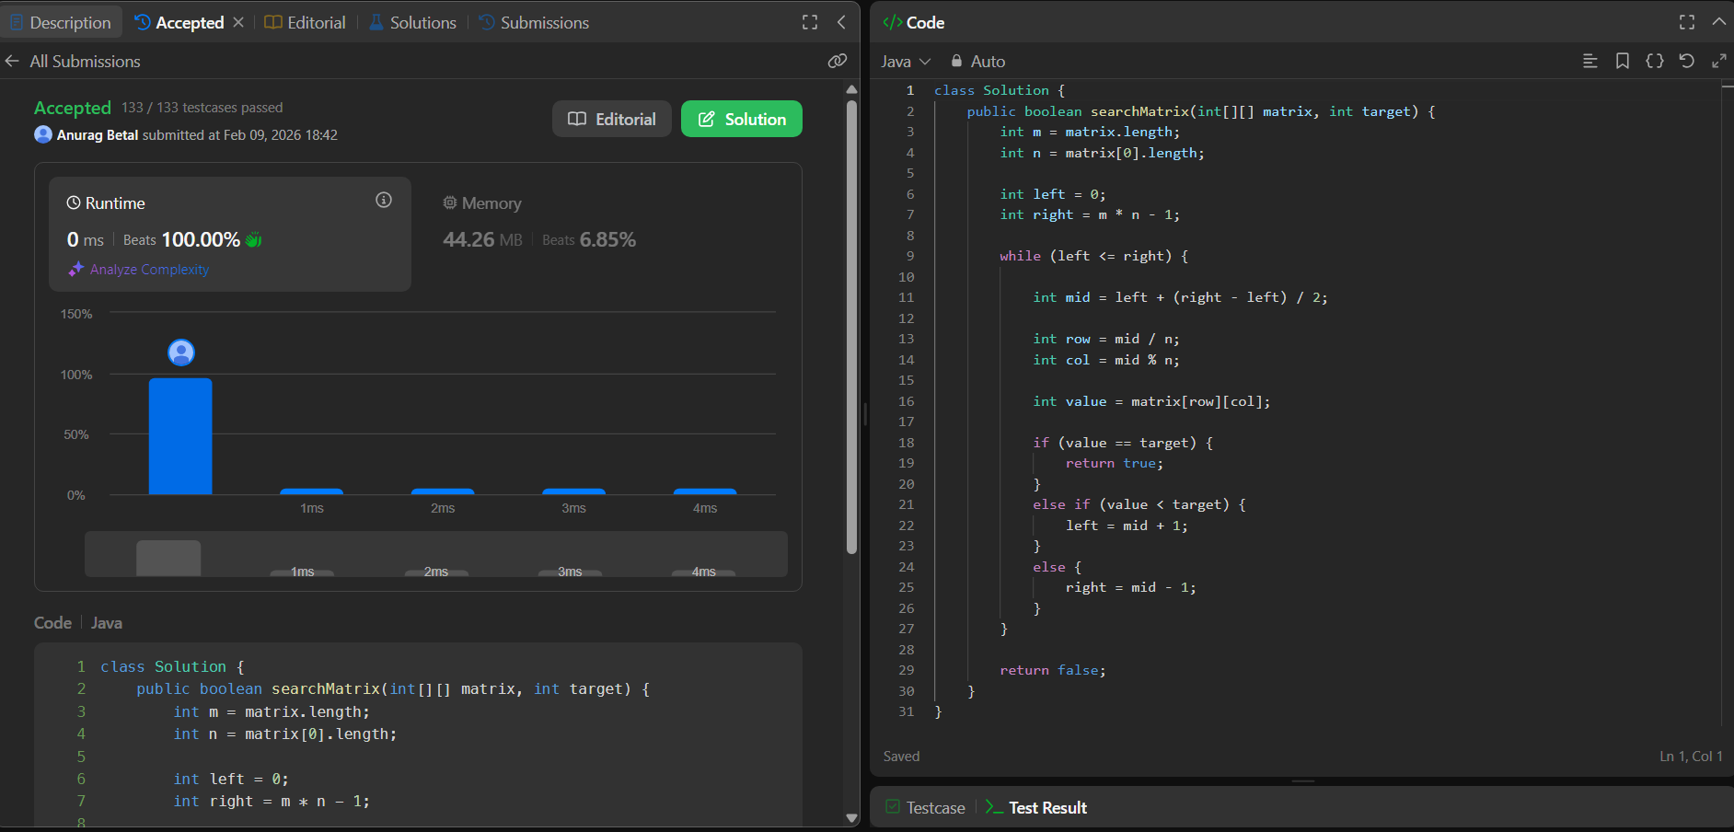
4.
You are given a 2D binary array arr[][] consisting of only 1s and 0s. Each row of the
array is sorted in non-decreasing order. Your task is to find and return the index of the
first row that contains the maximum number of 1s. If no such row exists, return -1.
Note:
• The array follows 0-based indexing.
• The number of rows and columns in the array are denoted
by n and m respectively.
Examples:
Input: arr[][] = [[0,1,1,1], [0,0,1,1], [1,1,1,1], [0,0,0,0]]
Output: 2
Explanation: Row 2 contains the most number of 1s (4 1s). Hence, the output is 2.
Input: arr[][] = [[0,0], [1,1]]
Output: 1
Explanation: Row 1 contains the most number of 1s (2 1s). Hence, the output is 1.
Input: arr[][] = [[0,0], [0,0]]
Output: -1
Explanation: No row contains any 1s, so the output is -1.
Sol
